**How to create an automated task using Task Scheduler on Windows 10**

Task Scheduler allows you to automate many tasks on Windows 10, and in this guide, we'll show you the steps to create and schedule your first task.

## How to create a basic task using Task Scheduler

To create a task using basic settings on Windows 10, use these steps:

1. Open **Start**.
2. Search for **Task Scheduler**, and click the top result to open the experience.
3. Right-click the "Task Scheduler Library" branch, and select the **New Folder** option. 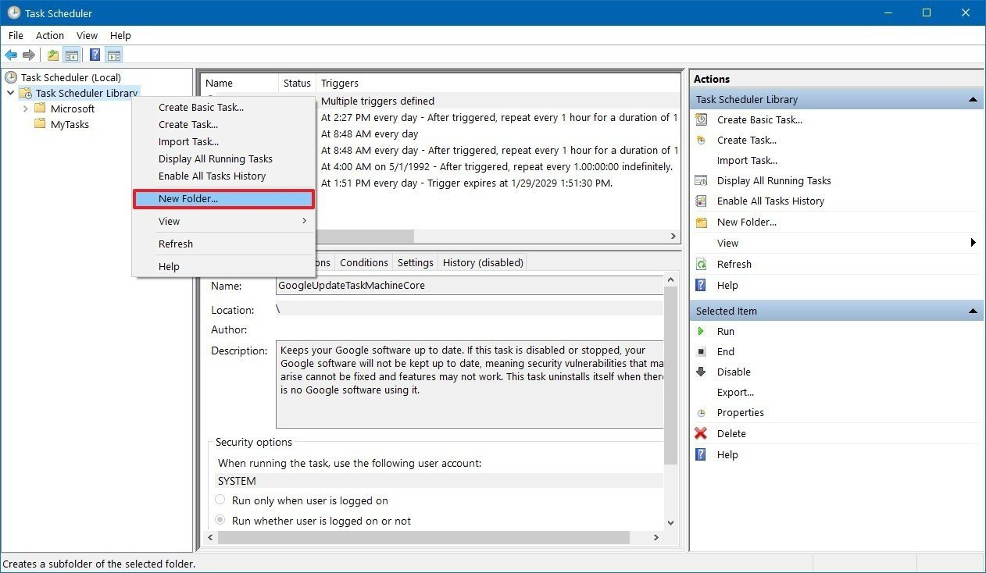
4. Type a name for the folder. For example, MyTasks. (This step isn't a requirement, but it's a recommended step to keep your tasks separate from the system and apps tasks.)
5. Click the **OK** button.
6. Expand the "Task Scheduler Library" branch, and select the **MyTasks** folder.
7. Click the **Action** menu.
8. Select the **Create Basic Task** option. 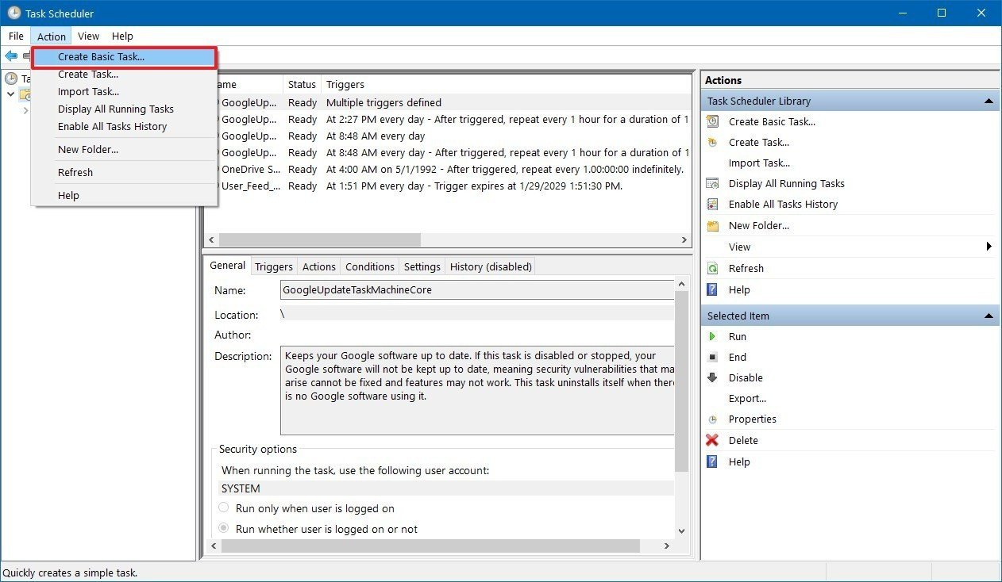
9. In the "Name" field, type a short descriptive name for the task. For example, Notepad Launcher. 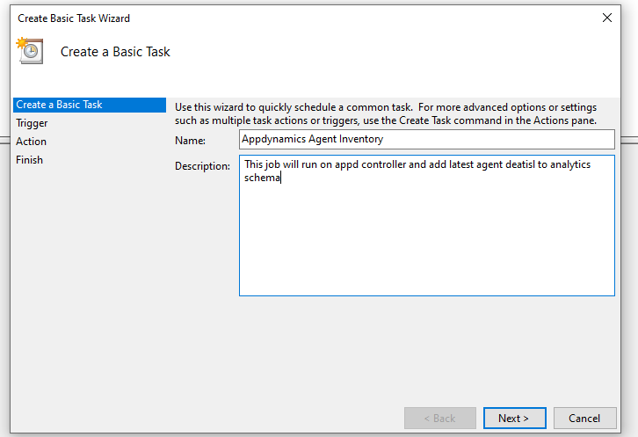
10. (Optional) In the "Description" field, create a description for the task.
11. Click the **Next** button.
12. Select the **Daily** option. 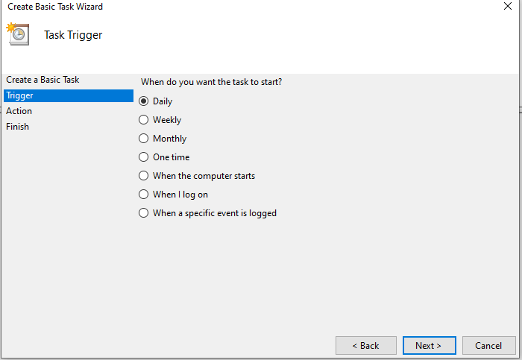 Task Scheduler allows you to select from a number of triggers, including on a specific date, during startup, or when you or a particular user signs in. Depending on your requirements, you'll need to configure additional parameters. In this case, we'll be selecting the option to run a task every month.
13. Click the **Next** button.
14. Using the "Start" settings, specify when the task should start running and the time (very important).
15. Use the Date & Time menu that you want to run the task. 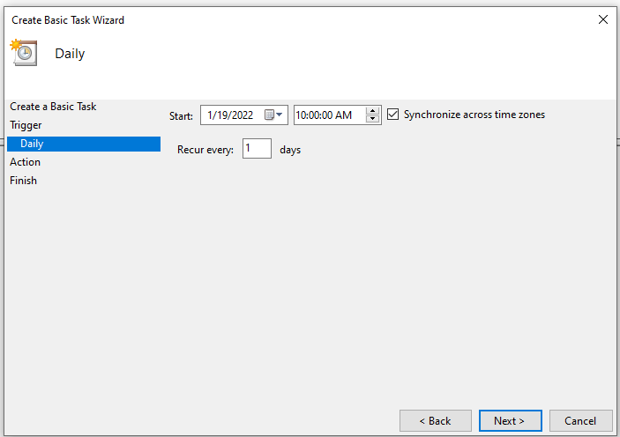
16. Click the **Next** button.
17. Select the Start a program option to launch an app, run a command, or execute a script file.

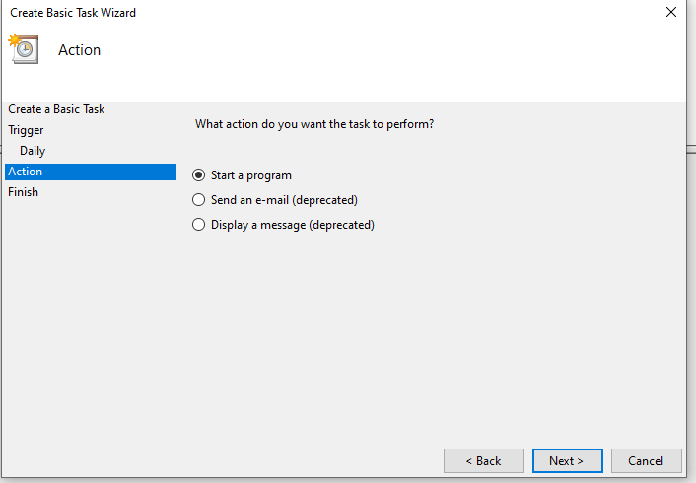 You can select the **Send an e-mail** or **Display a message** option, but these are deprecated features, which means that they may or may not work because Microsoft is no longer maintaining them.

* **Send an e-mail:** Triggers an email notification with a custom message on schedule, but it requires to specify an email server to work.
* **Display a message:** Allows to display a text message on the screen on schedule.

1. In the "Program/script" field, specify the path for the application. 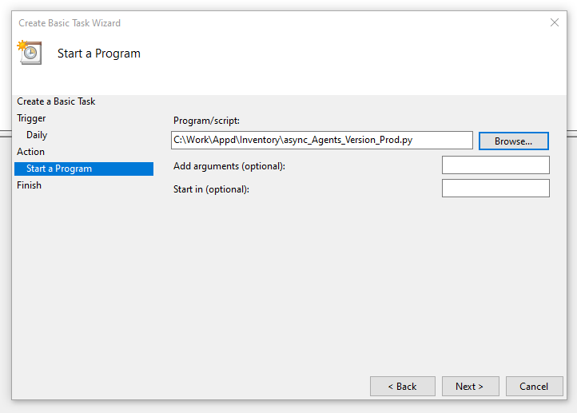 **Quick Tip:** If you don't know the path of the app, click the **Browse** button to find it.
2. (Optional) In the "Add arguments" field, you can specify arguments to run the task with special instructions.
3. (Optional) In the "Start in" field, specify the folder in which the program will start. (Usually, you can leave this setting empty.)
4. Click the **Finish** button. 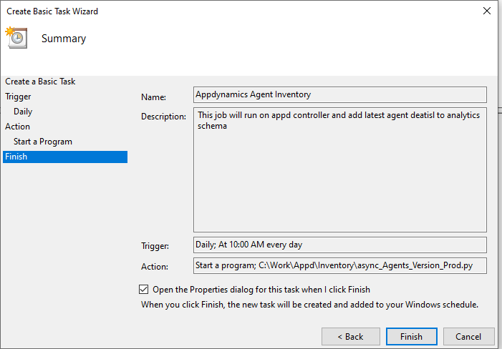 Once you've completed the steps, the task will be saved, and it'll run automatically on the schedule you specified. 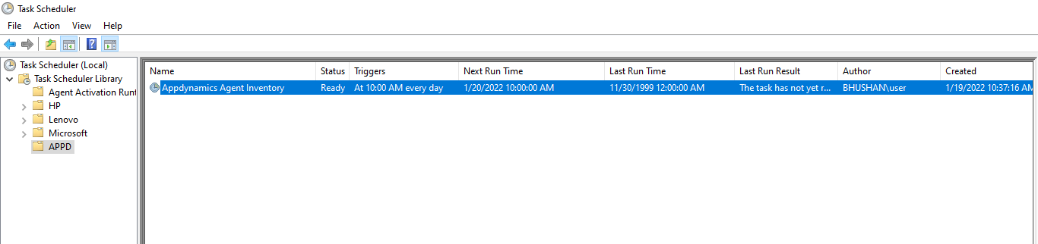
5. Double click on task and you will some additional setting for your scheduled job 